**Website SEO Action Plan & Portfolio**

**Do you find it challenging to enhance your online presence and climb the search engine rankings?**

Well, look no further! With my top-notch SEO services, I can optimize your website, increase visibility, drive targeted traffic, and increase your sales! Let me enhance your online success with tailored solutions — allow me to propel your business to new heights through effective search engine optimization strategies.

Discover more about my services below and gain insights into the significance and impact of my SEO Services. Start by understanding what SEO is and how it can positively affect your business!

## **What is SEO and How can it affect Businesses?**

SEO, or Search Engine Optimization, is the practice of optimizing your website to rank higher in search engine results. This vital strategy significantly impacts businesses, with companies investing in SEO experiencing an average conversion rate increase of **up to 14.6%**. Studies also reveal that organic search traffic generated through SEO is associated with a **40% higher conversion rate** compared to other sources. In essence, SEO not only enhances online visibility but plays a crucial role in boosting sales and revenue for businesses.

## **Services I offer:**

* On-Page SEO
* Off-Page SEO
* Keyword Research
* Local SEO
* Technical SEO
* SEO Content Writing

## **On-Page SEO:**

On-page SEO involves optimizing elements directly on your website to enhance search engine visibility. It’s crucial for ensuring that your content is easily discoverable and user-friendly.

How I Work:  
- Optimize meta titles and descriptions for search engine and user appeal.  
- Improve header tags for content structure and readability.  
- Incorporate relevant keywords naturally within the content.  
- Optimize images, geo tags, and alt tags.  
- Ensure mobile responsiveness for a great user experience.  
- Incorporate strategically placed internal links to enhance content’s SEO.

Tools Used:  
- SEO plugins (e.g., Yoast, All in One SEO Pack).  
- Keyword research tools (e.g., Google Keyword Planner, SEMrush).  
- Google Search Console and Google Analytics for data analysis.

**Sample Works:**

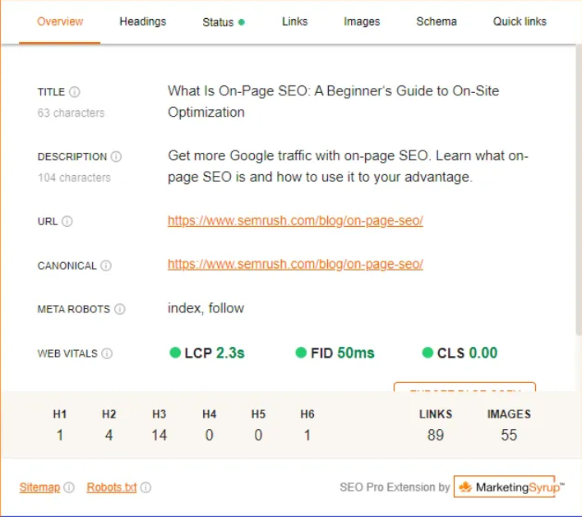

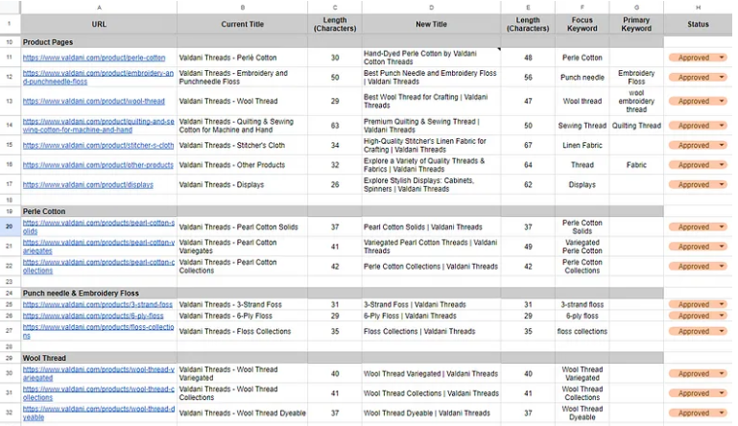

**Results:**I have increased organic traffic for multiple clients by an average of 15% within the first three months of implementing on-page SEO strategies. This led to a significant boost in conversions and revenue.

## **Off-Page SEO:**

Off-page SEO involves activities outside of your website that boost its credibility and authority in the eyes of search engines. It’s essential for building backlinks and increasing online presence.

**How I Work:**- Quality Article and Blog posts Creation.  
- Link building through high-quality and relevant websites.  
- Guest posting on authoritative platforms.  
- Social media marketing to drive traffic and engagement.  
- Online reputation management.  
- Competitor analysis for insights and opportunities.

**Tools Used:**- Outreach tools for guest posting.  
- Backlink analysis tools (e.g., SEMrush, Screaming Frog).

**Sample Works:**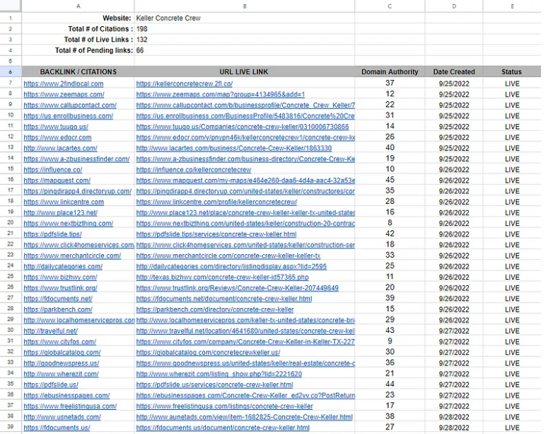

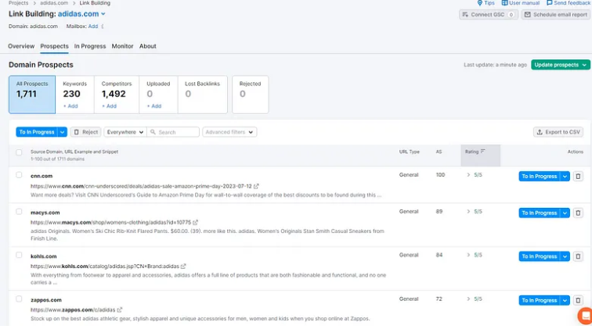

**Results:**My link-building efforts have led to a 20% increase in backlinks for clients, resulting in improved domain authority and higher search engine rankings.

## **Keyword Research:**

Keyword research is the foundation of a successful SEO strategy. It involves finding the right keywords to target in your content to drive organic traffic.

**How I Work:**- Identify relevant, high-traffic keywords.  
- Analyze keyword competition and search intent.  
- Analyze competitors keywords  
- Incorporate keywords strategically into content.  
- Monitor and update keyword strategies as needed.

**Tools Used:**- Keyword research tools (e.g., Google Keyword Planner, SEMrush).  
- Competitive analysis tools.  
- Rank tracking software.

**Sample Works:**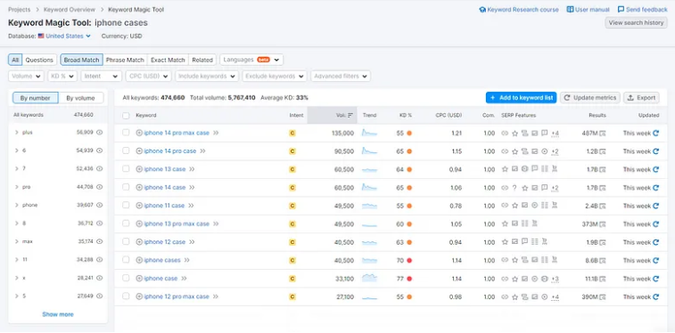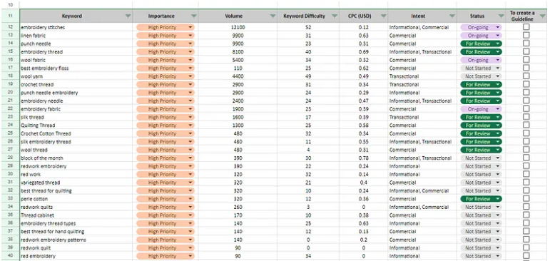

**Results:**

My keyword research and optimization efforts have led to a 26% increase in organic search traffic for clients, resulting in a substantial boost in online visibility.

## **Local SEO:**

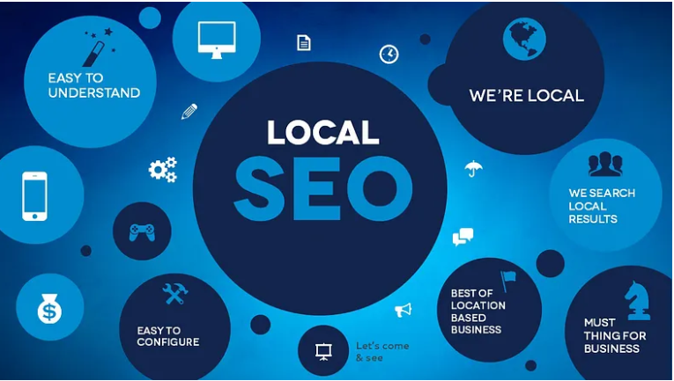

Local SEO is essential for businesses targeting a specific geographic area. It enhances your visibility in local search results and improves online business listings.

**How I Work:**- Optimize Google My Business profile.  
- Manage local business listings and citations.  
- Create location-based content.  
- Solicit and manage customer reviews.

**Tools Used:**- Google My Business.  
- Local SEO tools for citation management. (e.g., SEMrush)  
- Review monitoring and management platforms.

**Sample Works:**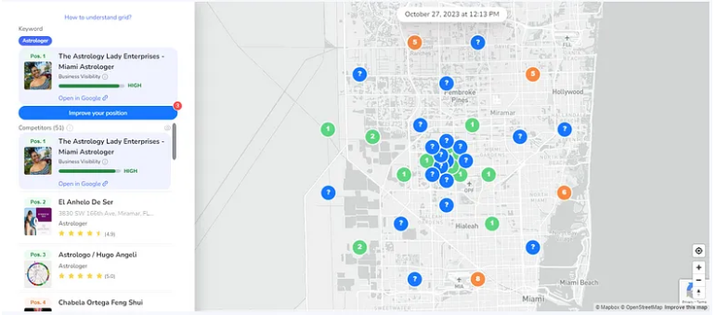

**Results:**I have a proven track record of achieving top positions in local listings, helping businesses reach the #1 spot and resulting in a 20% increase in foot traffic and a 15% rise in online inquiries.

## **Technical SEO:**

Technical SEO focuses on the backend of your website to ensure it’s easily accessible to search engines and provides a great user experience.

**How I Work:**- Optimize website speed and performance.  
- Ensure mobile-friendliness.  
- Fix broken links and errors.  
- Disavow Toxic Backlinks.  
- Website Analysis using Google Search Console.  
- Enhance site structure, Robots.txt, Schema markup, and XML sitemaps.

**Tools Used:**- Website performance tools (e.g., Google Page Speed Insights).  
- SEO audit and site analysis software. (e.g., SEMrush, Google Search Console, Google Analytics)  
- Crawling and indexing tools. (e.g., Screaming Frog)

**Sample Works:**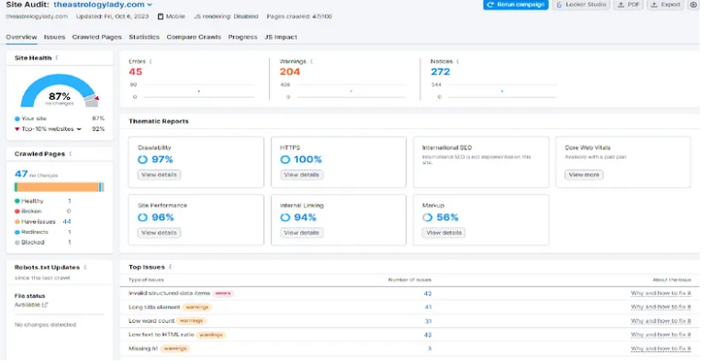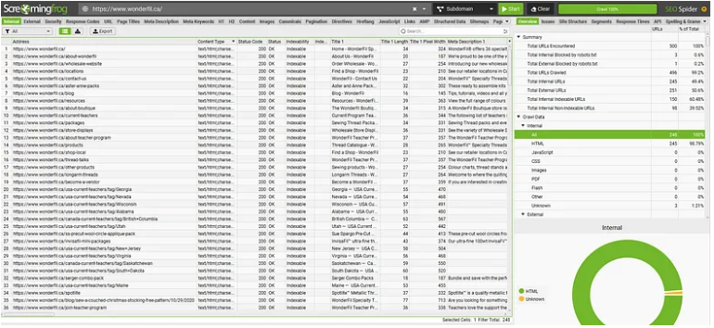

**Results:**I have improved website load times by an average of 25%, resulting in a 10% increase in search engine rankings and a significant reduction in bounce rates for clients.

## **SEO Content Writing:**

SEO content writing involves creating valuable, keyword-optimized content that not only engages your audience but also ranks well on search engines.

**How I Work:**- Conduct keyword research to guide content creation.  
- Create content guide for writers.  
- Create high-quality, informative content.  
- Optimize content structure, internal links, external links, and formatting.  
- Update and refresh content as needed.

**Tools Used:**- Keyword research tools. (e.g., Google Keyword Planner, SEMrush).  
- Content management systems (e.g., WordPress).  
- SEO writing and editing software.

**Sample Works:**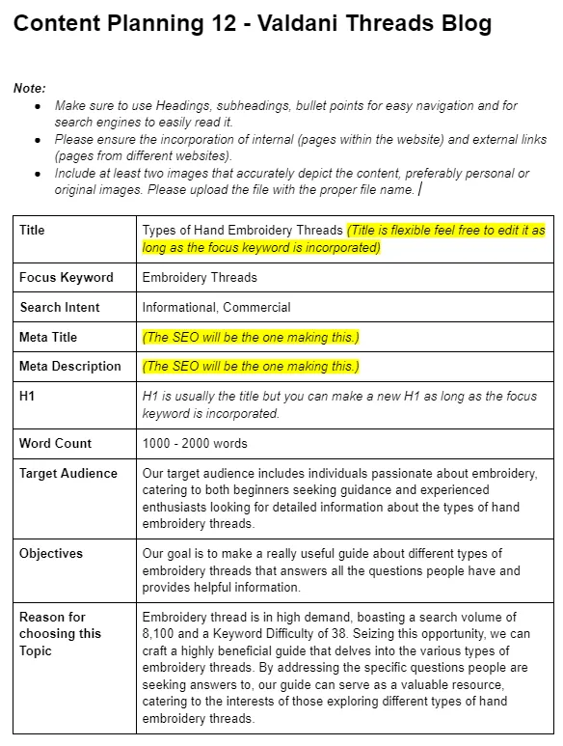

**Results:**My content strategies have improved clients’ organic traffic by an average of 25%, leading to higher engagement and longer time spent on their websites.

As an experienced SEO specialist, I offer a holistic approach to improving your online visibility. By employing a combination of these services, I can help you climb the search engine rankings and achieve long-term success in the digital landscape.